

**كلية العلوم الحاسوبية والمعلوماتية**

Faculty of CSI

**Project Title**

*Students:*

Yasmeen Huaasin Al-Halleeq 202120287

Abdulrahman Hameed Al-Zubeiry 202210660

*Supervisor:*

Dr. Alaa Abu Dhuwabeh

*Amman - Jordan*

*2024/2025*

**Table of Contents**

1.1 Problem Statement and project Scope page 1

1.2 Project Plan and Schedule

2. System Analysis page 2

2.1 Functional Requirements

2.2 Use Case Diagram

3. System Design page 3

3.1 Class Diagram

3.2 ER-Diagram

3.4Schema

3.3 User Interface

* 1. Problem Statement and project Scope:

With the increasing demands of daily work and personal obligations, many individuals find it challenging to prepare healthy meals at home due to time constraints and their busy schedules. Many commercially available meals and restaurant options rely on unhealthy ingredients, saturated fats, and preservatives, which negatively impact individuals' long-term health.

This project aims to develop a system that enables busy individuals to order healthy, home- prepared meals made with nutritional standards in mind, ensuring a balance of essential nutrients and minimizing unhealthy ingredients. Through this system, individuals will have access to balanced dietary options tailored to their needs, supporting their health and maintaining a nutritious daily food balance.

The system has been facing problems due to its paper-based appointment

system. With the increase in the number of patients visiting, it has

become diﬃcult to manage the appointment system manually. Recording

of appointments and creating registers by pen and paper has become a

* 1. Project Plan and Schedule:

The image shows a project plan for the "Healthy Food Online System," covering phases like research, design, development, and deployment for an online food sales platform.

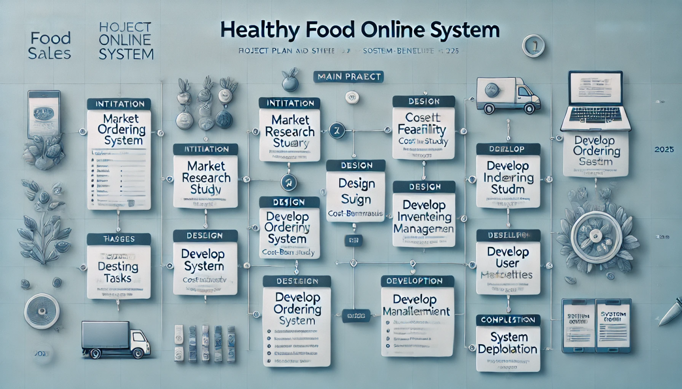

Figure 1: Gantt Chart of project

2. System Analysis:

2.1 Functional Requirements:

1• Order Registration: The system should allow users to place meal orders online.

2• Meal Menu Display: Provide a diverse menu with information on calories and nutritional values for each meal.

3• Dietary Customization: Allow users to customize meals based on their needs (e.g., low-calorie, gluten-free, or vegetarian options).

4• Delivery Scheduling: Enable users to select suitable delivery times.

5• Alerts and Notifications: Send alerts to users when their order is being prepared and notify them upon delivery.

6• Payment Options: Support multiple payment methods, such as online payment or cash on delivery.

3.1Non-Functional Requirements:

1. Performance: The system should be fast and capable of processing orders quickly.
2. Scalability: The system should be scalable to handle a large number of simultaneous users.
3. Security: Protect user data and payment transactions from unauthorized access and breaches.
4. Usability: The system should be user-friendly, with a simple interface suitable for all age groups.
5. Availability: The system should be available 24/7, with backups to prevent data loss.
6. Maintainability: The system should be designed for easy updates and regular maintenance without service disruptions.

2.2 Use Case Diagram:

The diagram shows the roles of the user, administrator, and delivery driver in an online food ordering system.

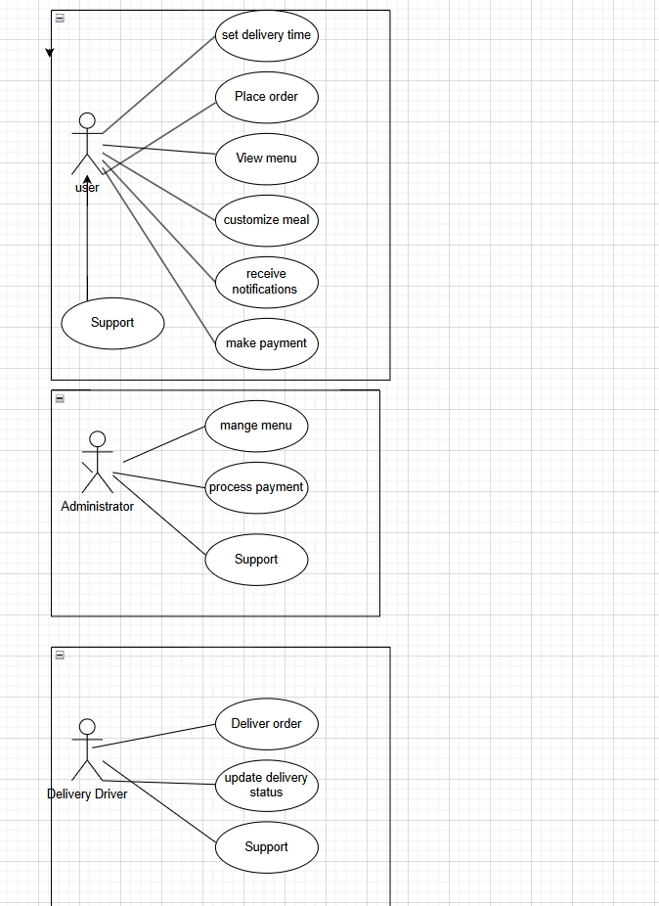

Figure 2: Use Case diagram of system

3. System Design

3.1 Class Diagram :

This diagram represents a class diagram for an online food ordering system, showing six main classes: User, Admin, Order, Meal, Payment, and Delivery. It details their attributes and methods, illustrating relationships and interactions within the system.

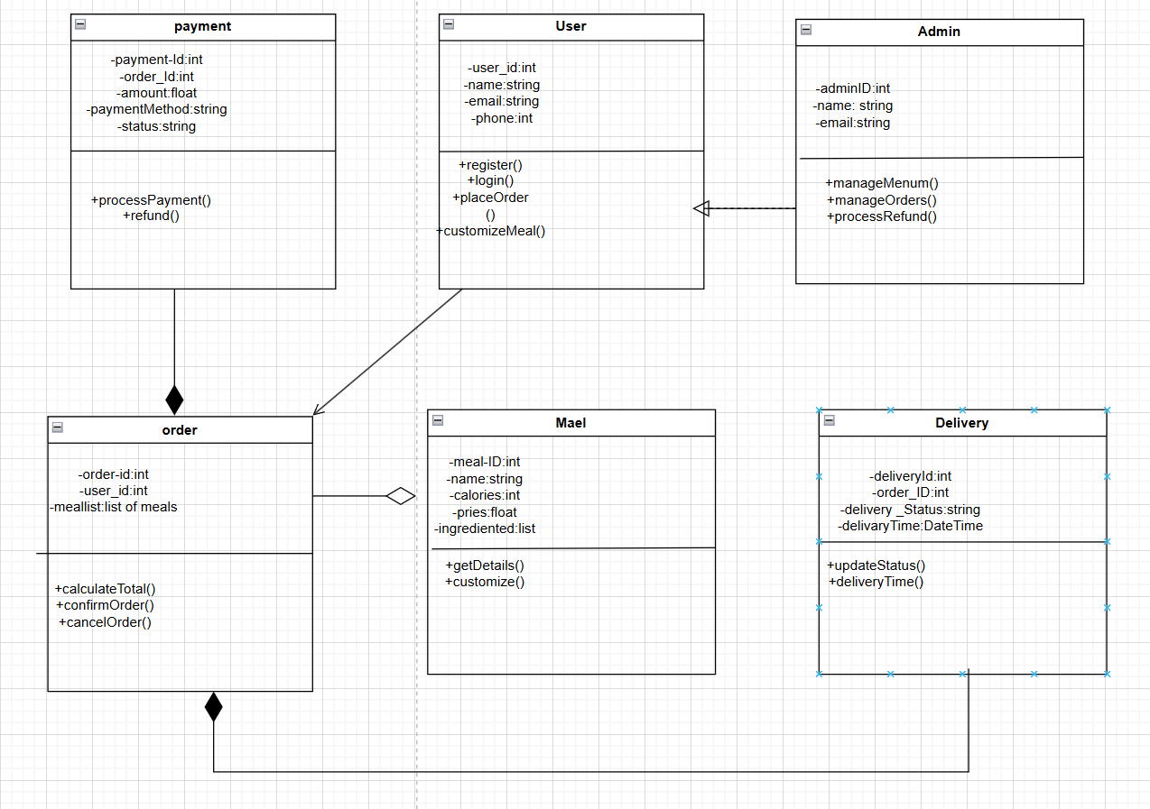

Figure 3: Class diagram of Appointment system

3.2 ER-Diagram:

The diagram represents the relationships in a food delivery system: a customer can place multiple orders (1),

an order can include multiple meals (M),

and a delivery driver can handle multiple orders (1).

It includes attributes for customers, orders, meals, and drivers.

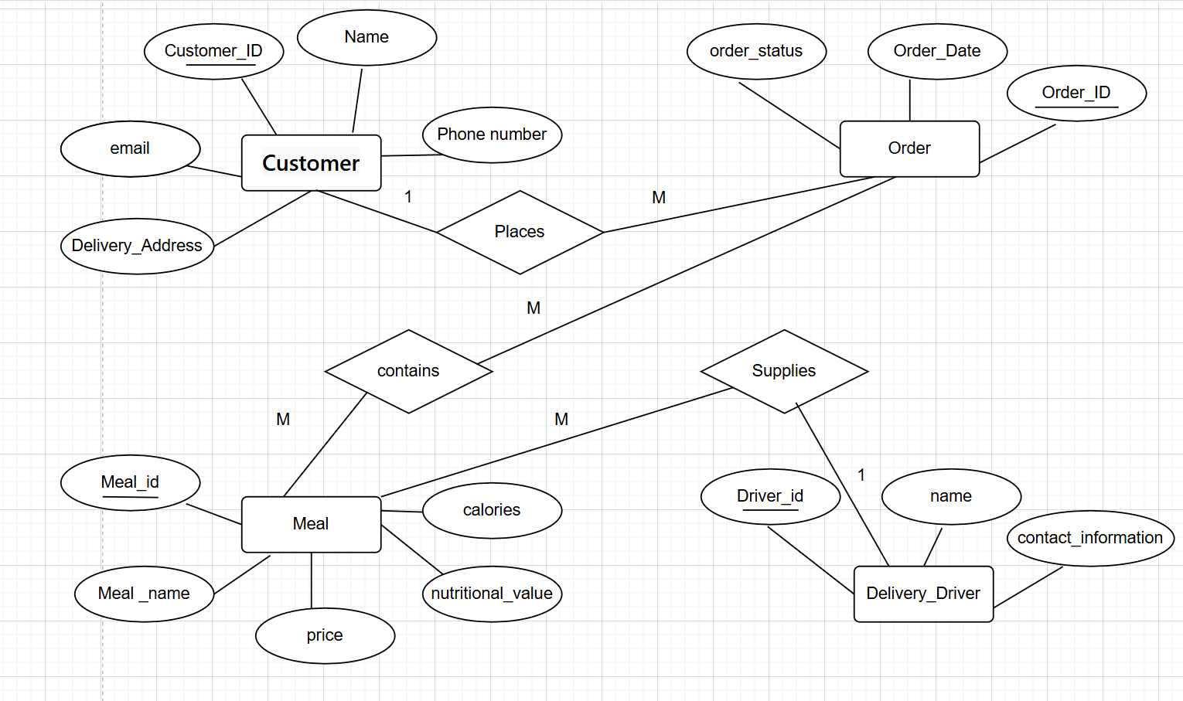

Figure 4: ER diagram of Appointment system

3.3schema:

The diagram outlines a food delivery database with tables for customers, orders, meals, drivers, and their relationships, including a many-to-many link between orders and meals.

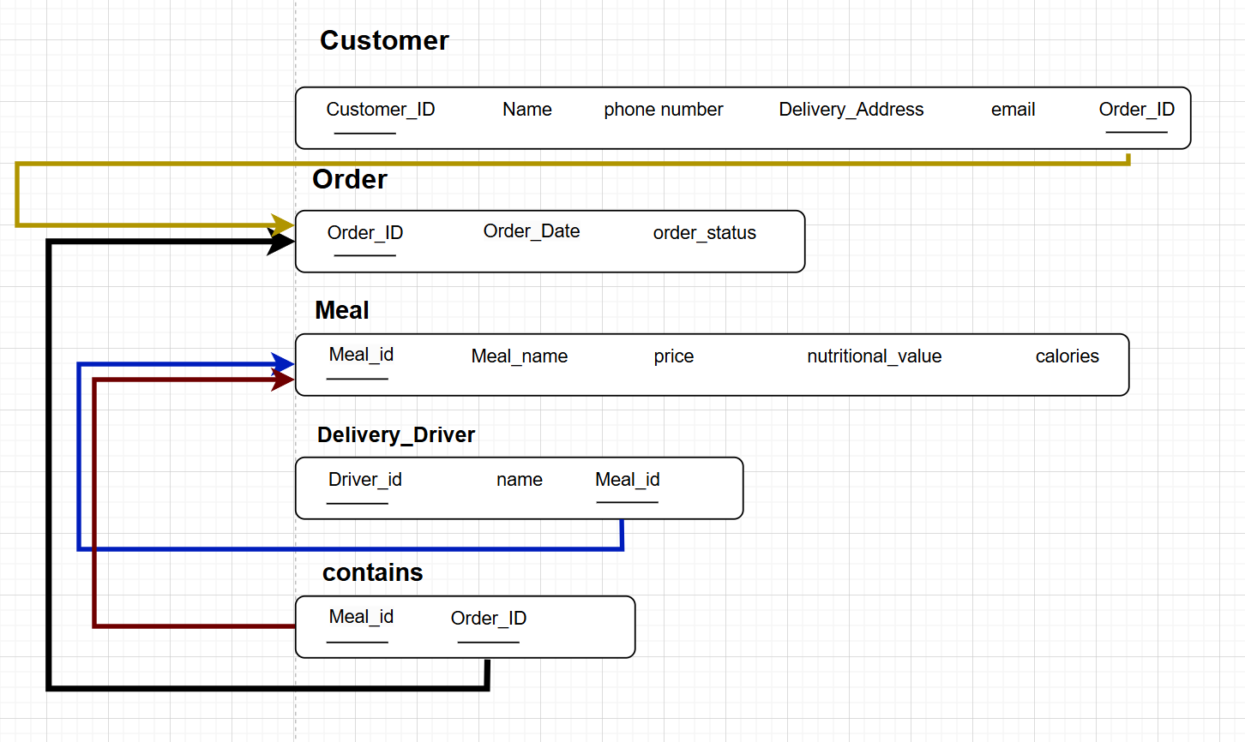

Figure 5: Schema of Appointment system

3.5 User Interface :

The image illustrates a user registration interface with input fields for name, password, and email, alongside visually appealing green-themed design elements. It integrates a mobile preview, suggesting compatibility with smaller screens.

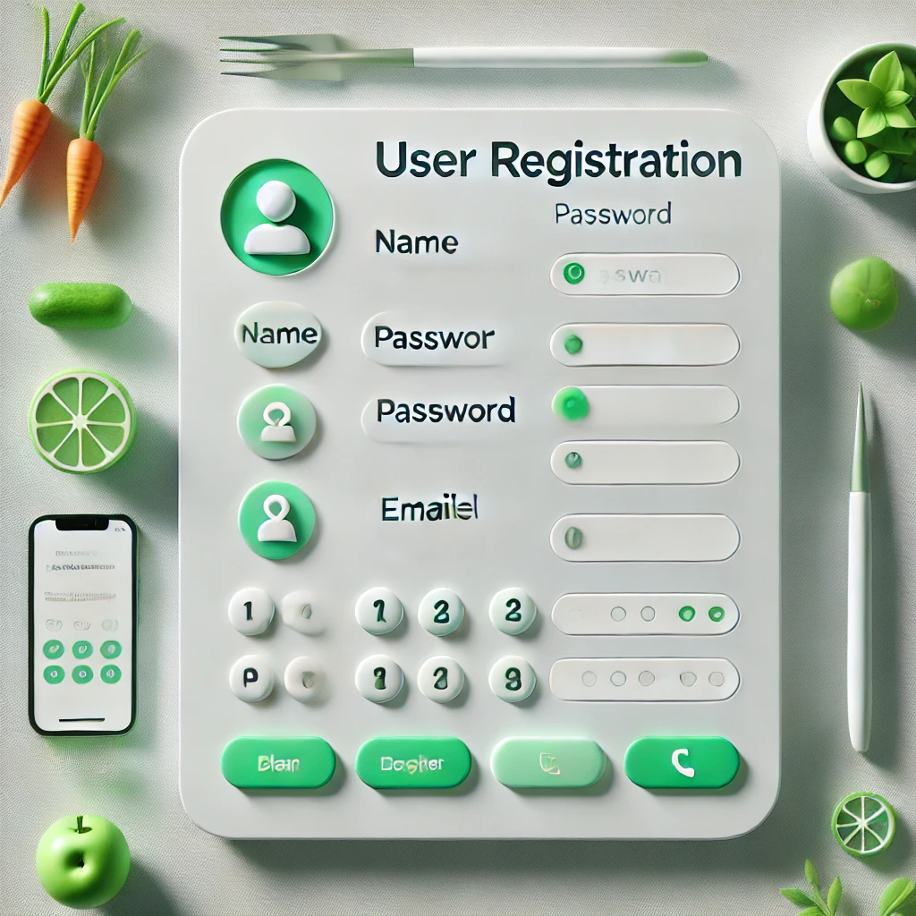

Figure 6: Main UI of Appointment system

The image shows two green-themed login and registration screens for a food-related app, featuring playful illustrations of vegetables, utensils, and dishes. Both screens include fields for entering user credentials like name, email, and password.

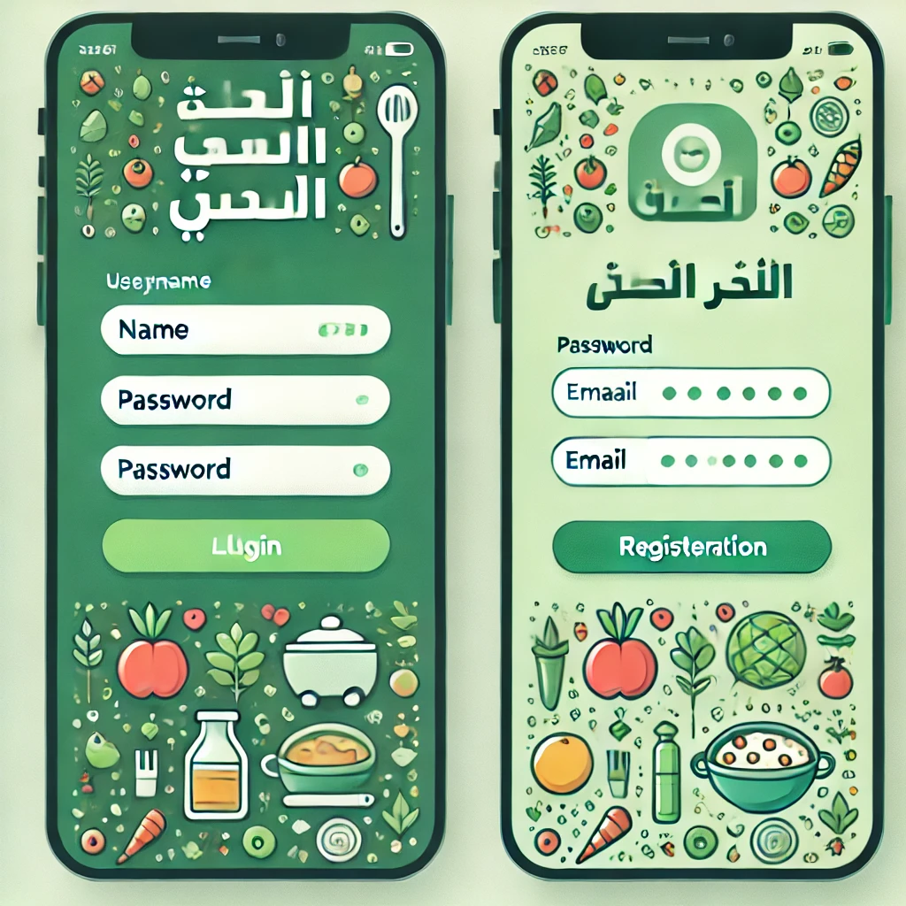

Figure 7: Show All UI of system

The image showcases a modern mobile app interface for a healthy meal delivery system. It features clean, minimalistic designs with vibrant food visuals and functionalities like meal customization, tracking, and ordering.

